**ASSIGNMENT INT-301**

**Question No 7: -**

Consider a php form with columns id, first_name, last_name, email_id. Insert following data in the database and fetch all the data in descending order of first_name.

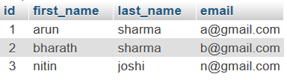

**SOLUTION: -**

PHP is a very popular scripting language that is especially suited to web development. Which help the developer to code with efficiency and with better output. In the above question we must create the form in which we have to include first name, last name and email id by using the php and other web development tools like HTML and CSS.

As you know we are living in the 4th revolution where we have technology like big data, data science and machine learning. In which data play the very crucial role for the industry and maintaining the data is very big task for that we need lots of tools and resources. While after creating the form for the user they will insert the data according to columns which has shown in above figure.

Many industries need the data for their business specially user name and email id to give them update regarding the products and its facility provided by the company so these thing can help in industry also for maintaining the user data which help for the betterment of company.

So, when user will insert their data in the form, we will store their data with the help of MySQL and after that we will fetch the data in the descending order according to user first name.

**DESCRIPTION AND TEST CASES: -**

1. Form: - Web pages are used to enter the user data and these data we can store in MySQL and after that we will fetched the data in descending order.

n

3. And after that store the data in the phpMyAdmin with the help of MySQL server

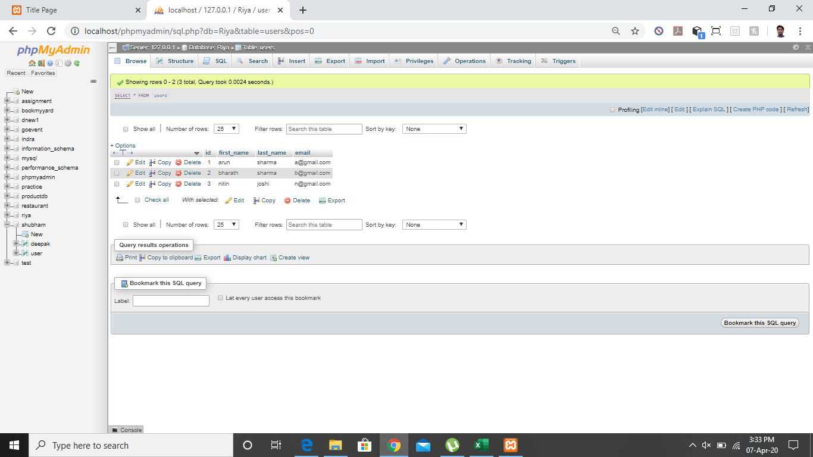

4. Displaying the data table: -

5. Code for form with the help of php, html and css

6. Database Code: -

Name: - Prajwal Kamale

Reg No: - 11602861

GitHub: - <https://github.com/prajwalkamale/CA2-INT301>